1. ​​​​​​​What's the Big Idea?

After receiving another "In" "Out" one-two punch from 67669d2d today, it occurred to me that the 2020 season of the DC Bloomberg Chain has come to a close.

1. ​​The Contest

While it would require literally zero game knowledge beyond occasionally moving emails into one's dedicated "tip of the bloomberg" email folder to know 67669d2d is leading the race, ***no one***could have predicted the full season results. Now that the proverbial dust has settled, we have seen that this competition was fierce. With comebacks and blunders to boot, I, for one, would be saddened to see the Bloomberg drama of 2020 go by without any commemoration for posterity. How could the RAs of 2028 *possibly*understand the tumultuous times of COVID if they don't know of 4dbc5a10's sporadic streaks or e5d310e0's consistent play style? The answer is clear as day: they couldn't.

1. ​​​​Overall Leaderboard

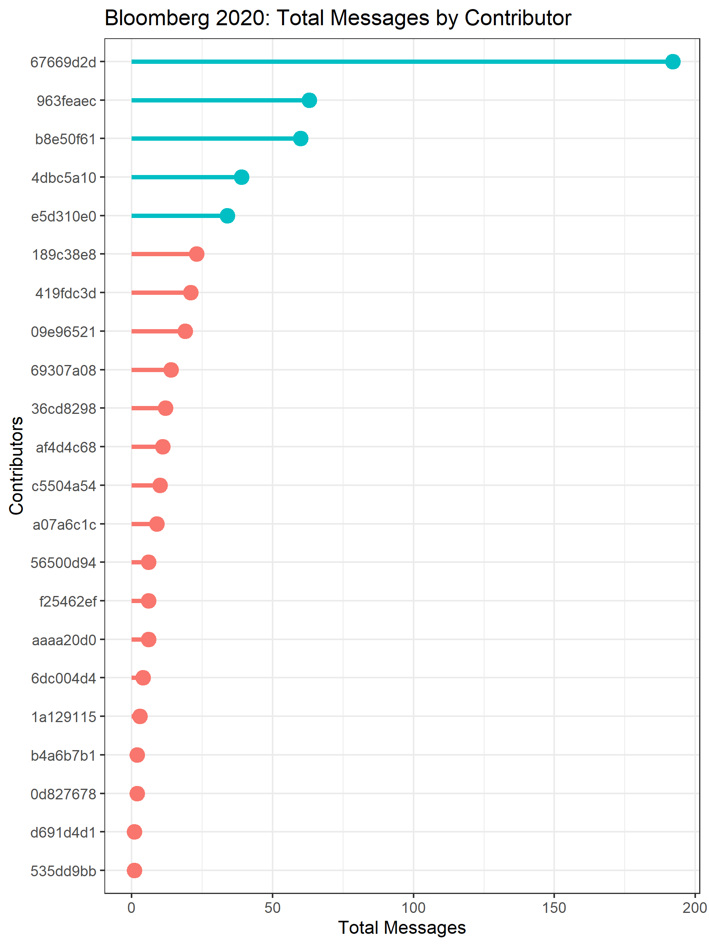

Breaking down the top five contribut​ors overall, we have:

* ​In Fifth with thirty-four messages, e5d310e0 has beaten out the majority of competitors, myself included.
* Just barely beyond e5d310e0 is 4dbc5a10, sitting pretty with thirty-nine. While a far cry from top dog, this is a truly comfortable position, with only seven other competitors notching more than half 4dbc5a10's score.
* In Third, coming up just short in the hotly contested race for Second, b8e50f61 trails 963feaec with sixty messages.
* Coming in Second with a terrific performance by all counts, 963feaec has locked in sixty-​three sends. If it weren't for 67669d2d, raising the bar about what this league even imagined possible, I expect the crowd would be completely satiated by a leading score of three-score and three more.
* Having emerged as a truly dominant force, 67669d2d has taken it upon himself to eviscerate the competition, standing so solidly in the top spot that even the combined performance of the other top-5 contributors would only surpass his ***one-hundred and ninety-two*** messagesby four. ***Wow.***

1. Drama as the Season Unfolded

From the overall score, one might reasonably suppose that 67669d2d has dominated the league since day one. However, that is not the case. In fact, this season has been a story brimming with twists and turns, unexpected upsets, and hot-streaks to rival Jeremy Lin circa 2012.

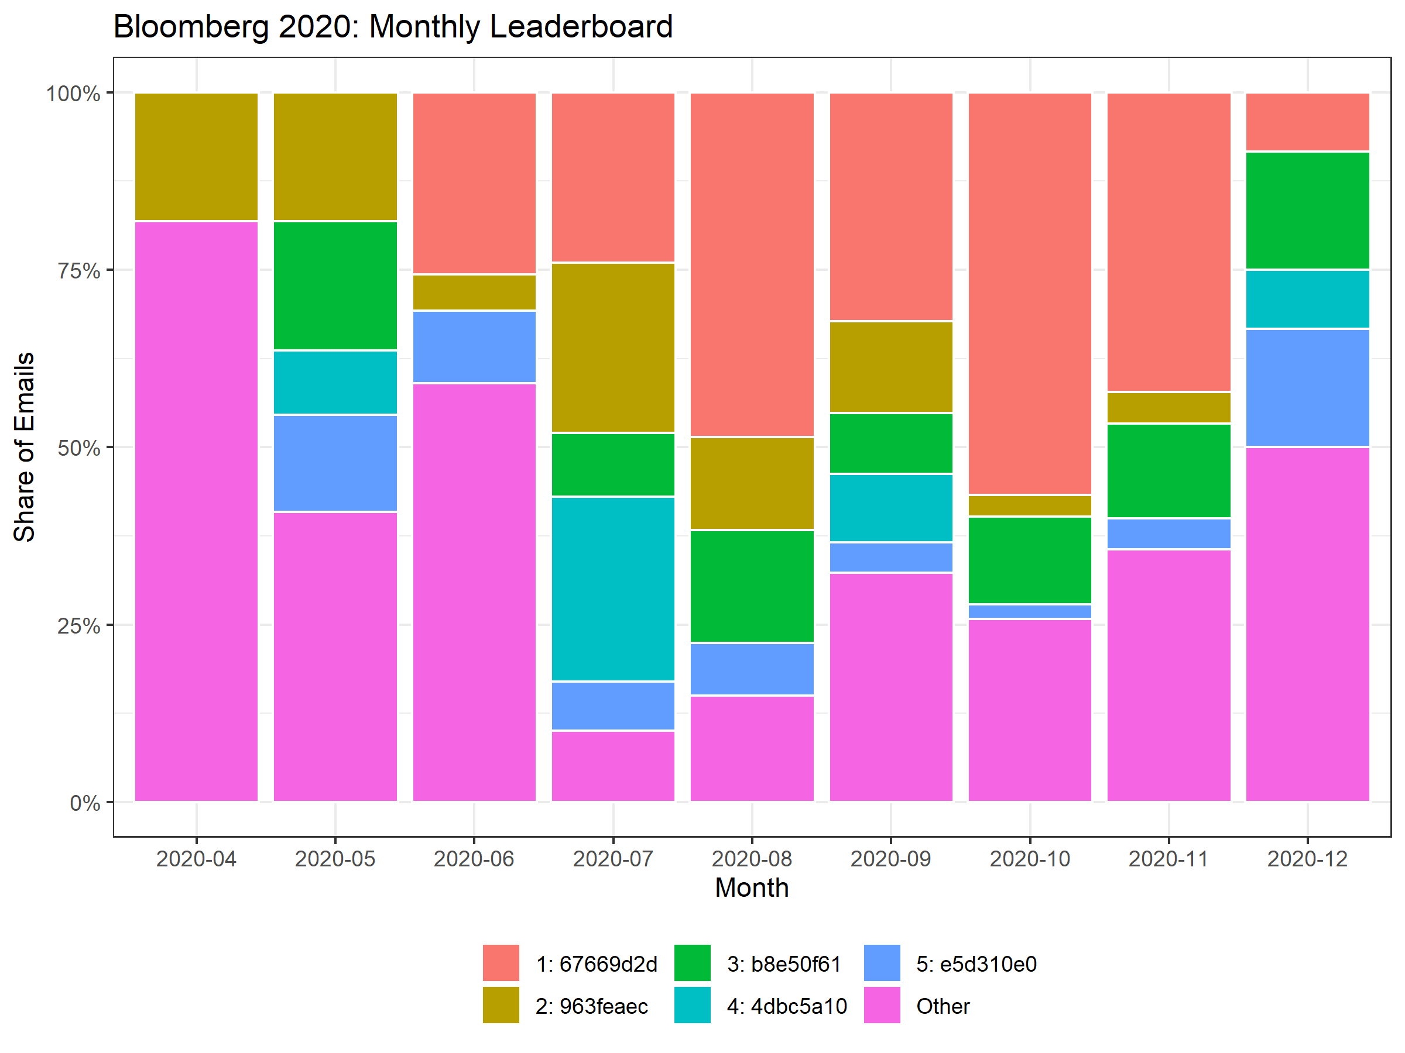

As you examine the monthly leaderboards, you immediately realize that the first month was the least dominated by the top five contributors, with only 963feaec contributing to the chain at all.

Furthermore, 67669d2d didn't develop his lust for blood until June, two months after the season began. Why he waited so long is unclear, and analysts will likely be digging into that question for seasons to come. However, once he joined the fray, 67669d2d made certain to establish himself as a key player by taking the top spot in June, tying for second in July, and unquestionably leading every other month until December.

Even as the limelight shifted towards 67669d2d, it's important to note that the [anonymized] and b8e50f61 each locked in eight months in the top five, sticking with the underappreciated "consistency-is-key" strategy. Unfortunately, for reasons known only to himself and the Bloomberg gods, 963feaec's streak of monthly contributions was broken in December. Many wonder if he will be returning to defend his position from b8e50f61, and some rumors are circulating that he is going to take the 2020 season as a farewell tour and bow out of the contest going forward. We'll just have to keep a keen eye on the 2021 season to find out for sure.

In contrast to strategies of consistency and delayed dominance, b8e50f61 opted for a more unconventional strategy based on episodic strong plays. Appearing infrequently, but refreshed, even unstoppable when present, b8e50f61 relied on performances in only four of the nine months in the 2020 season to send himself into fourth place. His run in July was particularly astonishing, locking down 26% of all messages after having been entirely absent in the previous month. Hopefully with coaching and offseason training, b8e50f61 will be able to convert those all-star streaks into consistent performances in order to compete with the best of the best.

1. Honorable Mentions

While I have focused primarily on the top five league contributors, there are many great plays from this season that involved some players who still have room to develop.

One legendary play that comes to mind was the comedic combination of [anonymized]’s banter in mid-October. Who could have guessed that the announcement of entering the fray was in fact a set up to [anonymized], whose deadpan delivery was rumored to intimidate new-hires so much that they abandoned the league entirely. While 36cd8298 used the event to gather momentum, eventually making into the top twelve, aaaa20d0 had a hard time converting that momentum into progress. After appearing in a press conference to explain his jokes, aaaa20d0 only made an appearance a handful more times, and finished up at sixteenth with a total of six messages.

Another set of plays that were critical to the success of the league were the initial plays of [anonymized]. While none of these three made it into the top five, their strong communication skills and initiative set the 2020 season into motion. Who knows, but I'd bet that a dominant force like 67669d2d could never have surfaced without 0d827678's strong examples in April.

1. ​In Conclusion

While 2020 delivered a long list of disappointments, the contest of the DC Bloomberg Chain was not one of them. This season was a pleasure to watch. While I​ hope to make a more substantial name for myself as a player in '21, I am happy to have been able to create this recap. I've included a table with each contributors total messages below, and look forward to seeing the updated figures as 2021 gets underway.

Cheers!  
Peter ​

​